**Redox Flow Batteries Applied For A Green Future—In The Perspective of Heat and Mass Transfer**

Qian Xu1,*, Qiang Ma1, Weiqi Zhang1, Fen Qiao2, Lei Xing3, Huaneng Su[1],*

1Institute for Energy Research, Jiangsu University, 301 Xuefu Road, Zhenjiang, 212013, China

2School of Energy and Power Engineering, Jiangsu University, 301 Xuefu Road, Zhenjiang, 212013, China

3Institute of Green Chemistry and Chemical Technology, Jiangsu University, 301 Xuefu Road, Zhenjiang, 212013, China

**ABSTRACT**

The global energy crisis is making energy storage as a critical technology in the use of renewable energy sources, such as wind and solar power, which have the intermittent nature. Among emerging technologies, the redox flow battery (RFB) is a promising candidate for large-scale stationary storage applications due to its unique features, including tolerance to deep discharge without any risk of breakdown, long lifetime, independance of power and capacity, and simple structure. However, the RFB technology is still hindered by several challenging issues before its widespread commercialization. For given electrolyte and electrode materials, the performance of the RFB is basically determined by the heat, mass and charge transport characteristics on the electrolyte-electrode interface and in the porous electrode. A better understanding of these coupled characteristics thus becomes essential for improving the battery performance. Hereby, we present a mini-review to reveal the recent progresses in RFB, with an emphasis on understanding the transport characteristics as well as the effects of operating conditions. By careful arrangements of flow regime and operating temperature, the cell performance as well as system efficiency can be greatly improved. In addition, some key transport parameters can be determined via electrochemical method using a RFB structure. Finally, a better criterion for cell performance evaluation is proposed.

**KEYWORDS**

redox flow battery; transport characteristics; operating conditions; cell performance

**1. INTRODUCTION**

Nowadays energy is one of the leading topics for concern of the society. Without secure, sustainable and economic energy, most of the modern civilization would fail. To maintain the energy-demanding society, large-scale use of CO2-emitting fossil fuel and the exhaustion of fossil energy reserves have a large impact on the already severe environmental issues in our planet. Hence, using and developing renewable energy sources, notably wind and solar power, is urgent for the sustainable development in a global scale. However, due to their intermittent nature, the potential of these energy sources can not be fully exploited without efficient, safe, reliable and cost-effective electrical energy storage systems are available. Energy storage systems will also be crucial to improve the robustness and efficiency of the distribution grid by peak shaving and load leveling [1].

There is a variety of available energy storage technologies, but there is no technology being suited to serve all applications. A comparison between storage technologies can make sense only when relating to a certain application. The application of various energy storage technologies depend on their power and storage capacities [2]. The comparison actually is very formidable, due to the various parameters that formulate the technical and economical performance of a energy storage system [3]. When we discuss flexibility options, it becomes clear that the gas storage systems and thermal storage systems also need to be discussed (See Fig. 1).

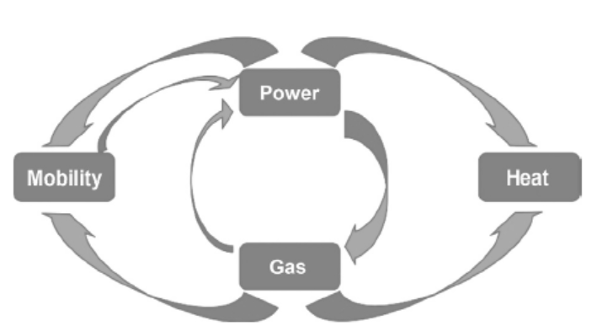

Fig. 1. Intersectoral connection of energy systems.

Over the past few decades, the demand for electrochemical energy storage has been growing rapidly. In response, battery chemists have made tremendous improvements in the storage capacity and power density of batteries [4, 5]. To increase the energy density of a energy storage system, the lithium ion batteries have been proposed [6] and its energy density (180-250 Wh kg-1) is several times larger than any other conventional rechargeable battery including lead-acid (30-40 Wh kg-1) and nickel-cadmium (40-60 Wh kg-1).

However, one significant drawback of conventional batteries is that the electrodes serve as both the structural component and the electrochemically active materials, thereby leading to the coupling of the power density and storage capacity. These unfavorable characteristics of conventional batteries can be addressed if the active materials are decoupled from the power components. In line with this idea, the redox flow batteries (RFBs) have been proposed, as shown in Fig. 2.

For a RFB, the electrolyte solutions for both anode and cathode, which are seperated by a membrane or seperator, flow through porous electrodes and the active redox couples dissolved in the electrolytes react on the surface of electrodes. The generated electrons flow through the external circuit, and the charge-carrying species transport through the separator to form a cycle of electricity. Unlike the situations in other batteries, in redox flow batteries the energy is stored in the electrolyte solutions such that the capacity of the system depends on the concentration of the active species. The energy capacity and power density of a RFB system can be separately designed according to the requirements. In this sense, redox flow batteries are the most suitable candidate for massive energy storage as they allow the storage capacity to be scaled up readily by increasing the amount of active material while keeping other components unchanged. Furthermore, flow batteries can be discharged deeply without any potential damage to the electrode or the electrolyte materials. Since 1970s, various flow battery systems have been proposed [7-11]. Some redox flow batteries, such as zinc-bromine and zinc-cerium categorized as hybrid flow batteries since they save energy in the form of electrodeposits from one or more of the active components.

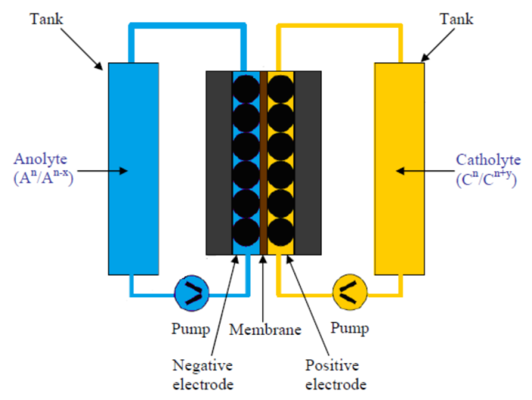

Fig. 2. Schematic of a redox flow battery (RFB) system.

Aiming to a better understanding of the coupled mass, heat transfer and electrochemical reaction processes inside the RFB, we propose this mini-review paper. It is arranged as follows. Firstly the key transport parameters in the porous electrode were determined via electrochemical method, then the effects of flow regime and temperature on the cell performance were investigated both experimentally and numerically, followed by the effects of operating conditions on system efficiency. Finally, some conclusions and the prospective are given.

**2. DETERMINATION OF KEY TRANSPORT PARAMETERS IN RFBS**

For determining the effective diffusivity inside a porous electrode, the main idea is to measure the mass flux given a concentration difference through porous electrode. The direct determination of the mass flux is quite challenging. In Reference [12] an electrochemical method is proposed for determining the effective diffusivity through porous electrodes.

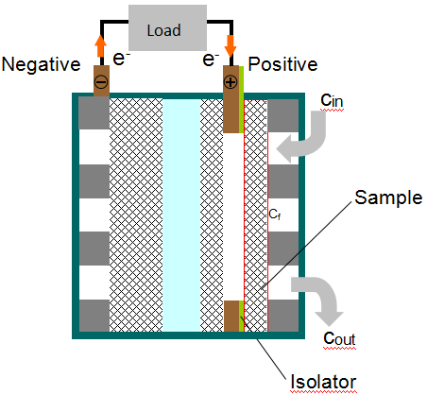

Fig. 3. Schematic of the setup for the determination of the effective diffusivity.

Fig. 3 shows the experimental setup, which is actually a VRFB. The tested porous sample and a membrane-electrode assembly are separated by a metal ring, which serves as a current collector. A serpentine flow field is used to supply and distribute electrolyte onto the surface of porous electrode, where the concentration of the vanadium ion, *cf,i*, would be approximated the same as that at the inlet of the flow field, if i) the concentration difference between the serpentine flow field inlet and the bulk would be very small; and ii) the electrolyte could evenly distributed onto the porous electrode surface. Transported through the porous sample, the vanadium ion is then flows through the gap between the porous sample and the catalyst layer (another thin porous electrode), where it reacts at a concentration, *cs,i*. Under this condition, the mass flux from the serpentine flow field to the thin catalyst layer can be expressed only as a diffusion flux.



Fig. 4. Mass-transfer correlation, *Deff/D* vs. Pe.

The limiting current densities were measured by changing the flow rate from 5 to 40 ml min-1. The measured data were then calculated to the effective diffusivity by Eq. 1, as shown in Fig. 4. The correlation was obtained based on a least square fit of the experimental data as follows:

 (4.3<Pe<34.5) (1)

Next step, the flux of mass transfer from the representative elementary volume (REV) level to the solid surfaces of electrode through internal pores needs to be determined under the situation that the concentration at the REV level *cb* and that at solid pore surfaces *cs* are given values. Xu and Zhao conceived an electrochemical approach as follows [12]. The electrolyte with concentration *cb* is transported via the internal pores to the solid surface of the electrode, where redox reactions occur. When the porous layer is sufficiently thin (e.g. only several pore diameters), the resistance of mass transfer from flow field to the porous layer becomes ignorable [13]. Hence, the concentration at the REV level can be approximated equalled to that in the flow field. Note that when the current density reaches the limiting current density, the concentration at solid pore surface of the porous layer (i.e. the electrode of the VRFB) becomes zero, implying that the mass-transfer coefficient at the pore level *km* can be determined by measuring the limiting current density and with a given concentration *cb*. The correlation of *km* (m s-1) was obtained based on a least-squares fitting of experimental data as follows:

 (0.3<Re<2.4) (2)

By adding an extra electric field on the half cell of a RFB, the mobility of ions in the electrolyte can also be determined, as illustrated in a recent patent [14]. The determined transport parameters can be further used in numerical modelings of RFBs for an improved accuracy [15].

**3. EFFECTS OF FLOW REGIME**

Known a critical component of flow batteries, the flow field functions to distribute electrolytes and to apply/collect electric current to/from batteries. The key issue of the flow field design is how to maximumly facilitate the mass transport under a minimum pressure drop. The three cell architectures were tested for the RFBs: one was the conventional flow-through electrode structure; one was with a serpentine flow field; and the other was with a parallel flow field onto the porous electrode. The performances of the RFBs with and without a flow field were measured and compared and the results show that adding a flow field in the cell can enhance the mass transport at higher flow rates, resulting in better cell performances. However, the pressure drop through the RFB with a flow field is also greatly enlarged compared with the flow-through arrangement at high flow rates. Taking account of both the cell performance and the pumping power, a power-based efficiency was defined and calculated at different electrolyte flow rates [16]. It is shown that there is an optimal flow rate for the VRFBs with a specific flow field, respectively, at which the maximum efficiency can be attained (see Fig. 5).



Fig. 5. Power-based efficiency vs. flow rate.

Fabricating with the optimized thickness of electrode and operating at the optimal flow rate, the redox flow battery with a serpentine flow field exhibits the highest energy efficiency [17].

Recently, Wang et al. proposed a transient model for VRFB. Based on their model, a dynamic flow-rate control strategy is proposed to determine the optimal flow rate under changing discharge power and state-of-charge (SOC) situations [18]. The numerical results show that the newly-proposed control strategy can result in a VRB system efficiency as high as 87.7%, and can control the temperature of electrolytes to the safe range during summer days.

**4. EFFECTS OF OPERATING CONDITIONS**

The effect of the operating temperature on the cell performance of a vanadium redox flow battery was experimentally studied by Zhang et al.[19]. Their results show that the flow battery’s voltage improved within the temperature range from 15°C to 55°C, because of the improved kinetics and reduced ohmic resistance. The voltage efficiency rised from 86.5% to 90.5% with the current density of 40 mA cm-2 and the peak power density enlarged from 259.5 to 349.8 mW cm-2. Moreover, the pumping consumption was lowered since the viscosity of the electrolyte decreases with temperature. On the other hand, at elevated temperatures the permeability of vanadium ions through the membrane increases, which would not only cause a decrease in the coulombic efficiency (CE), but also a faster capacity dropdecay. Their results imply that the thermal management of a practically operating VRFB is essential to make the battery operate at the optimal temperature to achieve the most high-efficiency operation.

The viscosity of the electrolyte in VRFBs keeps changing during charge and discharge processes as the concentrations of acid and vanadium ions in aqueous electrolyte continuously vary with SOC. Xu et al. proposed a 2-D model including the SOC-dependent viscosity to study the distributions of overpotential, local current density and vanadium ions concentration of a single vanadium redox cell [20]. The results from this model exhibit higher pressure drop (especially in the positive half-cell), steeper distributions of local current density and overpotential in the electrodes compared with the results resulting from a constant-electrolyteviscosity model, which implies that this improved model enables a more realistic modelling and more accurate estimation of pump consumption work in a VRFB.

During the operation of a RFB, there are several kinds of unwanted processes that decrease the cell performance and system efficiency, e.g. the hydrogen evolution reaction (HER) and ions crossover through the seperator. Wei et al. carried out some experiments to investigate the HER in a VRFB [21]. The results exhibit that the operating temperature has a crucial effect on the rate of HER. In particular, compared with the V3+ reduction reaction, HER seems more sensitive to the variation of temperature. It is also shown that H2 evolves at a relatively low SOC, suggesting that attention should also be paid to the hydrogen evolution at the negative electrode in the very early charge process. In addition, the generated hydrogen gas at the negative side prefers to shape macroscopically observable bubbles on the electrode surface, covering the active sites for redox reactions, while the oxygen evolution (including CO2 production) at the positive electrode corrodes electrode surface and results in some oxygen-rich functional groups.

To reduce the harmful effect of ion crossover, Leung and Xu proposed a preparation method for a sol-gel derived silica nanocomposite anion exchange membrane (AEM) for vanadium RFBs [22]. The physical properties of the obtained membrane, including the area resistance, the ion-exchange capacity and the water uptake, are evaluated and compared with the pristine AEM and the Nafion cation exchange membrane (CEM). The results exhibit that the vanadium ions permeability through the silica nanocomposite AEM is about 20 % lower than that of the pristine AEM, and even one order of magnitude lower than that of the frequently used Nafion membrane. As a result, the rates of self-discharge and the capacity fade of the VRFB reduced substantially. The coulombic and energy efficiencies at the current density of 40 mA cm-2 are as high as 92% and 73%, respectively.

Based on the comprehensive understanding of the operation of RFBs, Xu et al. reviewed the development of performance evaluation criteria and clarified the choosing principle of the evaluation criteria, declaring that the system energy efficiency is the most important criterion, and power density or/and energy density are also significant on the premise of keeping high system energy efficiency for various types of redox flow batteries [23-25]. Adopting a proper evaluation criterion implies to circumvent the remaining challenges of RFBs, hence their results can be the useful guideline for the technology development and the practical deployment of flow batteries.

**5. CONCLUSIONS**

The redox flow battery (RFB) is a promising electrochemical energy storage technology for large-scale stationary applications. This paper summaries some recent findings for RFB with an emphasis on the understanding the transport processes and the effects of operating conditions. Through a sample RFB, the key transport parameters including effective diffusivity inside the porous electrode, pore-level mass transport coefficient and ionic mobility can be accurately determined. The RFB with a serpentine type flow field operating at the optimal flow rate exhibits the highest energy efficiency. The arrangement of flow regime for a RFB stack should also consider the trade-off among flow resistance, ionic resistance and dimensions of branches. Thermal management of a practically operating VRFB is vital to make the battery operate at the optimal thermal situation to achieve the most efficient and reliable working. With a deeper understanding on gas evolution reactions and ions crossover through the separator, the system efficiency of a RFB can be largely improved. Applying a better performance evaluation criterion recently proposed, the research society aims to circumvent the remaining challenges of RFBs in the near future.

**ACKNOWLEDGEMENTS**

The work described in this paper was fully supported by Grants from the NSFC, China (No. 21676126 and No. 51676092), a Grant from the Chinese Postdoctoral Foundation (No. 2015M571685), Six-Talent-Peaks Project in Jiangsu Province (2016-XNY-015), and a Project Funded by the Priority Academic Program Development of Jiangsu Higher Education Institutions (PAPD), China.

**REFERENCES**

[1] Yang Z, Zhang J, Kintnermeyer MC, Lu X, Choi D, Lemmon JP, et al. Electrochemical energy storage for green grid.Chemical Reviews 2011; 111(5): 3577-3613.

[2] Xu Q, Zhao TS. Transport and electrochemical characteristics in flow batteries. Lambert Academic Publishing Co., Germany, 2017.

[3] Moseley PT, Garche J. Electrochemical energy storage for renewable sources and grid balancing (1st Ed.), Elsevier, 2015:465–473.

[4] Thackeray MM, Kang SH, Johnson CS, Vaughey JT, Benedek R, Hackney SA. Li2MnO3-stabilized LiMO2 (M=Mn, Ni, Co) electrodes for lithium-ion batteries. Journal of Materials Chemistry 2007; 17(30):3112-3125.

[5] Chan CK, Peng H, Liu G, McIlwrath K, Zhang XF, Huggins RA, et al. High-performance lithium battery anodes using silicon nanowires. Nat Nanotechnol 2008; 3(1):31-35.

[6] Whittingham MS. Electrical energy storage and intercalation chemistry. Science 1976; 192:1126-1127.

[7] Thaller LH. Electrically rechargeable redox flow cells. 9th Intersociety Energy Conversion Engineering Conference (pp.924-928). 9th Intersociety Energy Conversion Engineering Conference, 1974.

[8] Skyllaskazacos M, Rychcik M, Robins RG, Fane AG, Green MA. New all-vanadium redox flow cell. Journal of the Electrochemical Society 1986; 133(5): 1057.

[9] Price A, Bartley S, Male S, Cooley G. A novel approach to utility scale energy storage regenerative fuel cells. Power Engineering Journal 1999; 13(3):122-129.

[10] Butler PC, Eidler PA, Grimes PG. Development of a zinc-cerium anologes redox flow batteries. Columbus, OH, 2001.

[11] Leung PK, Ponce-De-Leon C, Low CT, Shah AA, Walsh FC. Characterization of a zinc–cerium flow battery. Journal of Power Sources 2011; 196(11): 5174-5185.

[12] Xu Q, Zhao TS. Determination of the mass-transport properties of vanadium ions through the porous electrodes of vanadium redox flow batteries. Physical Chemistry Chemical Physics 2013; 15(26):10841-10848.

[13] You D, Zhang H, Jian C. A simple model for the vanadium redox battery. Electrochimica Acta 2009; 54(27):6827-6836.

[14] Xu Q, Su HN. An electrochemical method to in-situ determine the ion mobility in solutin. Chinese Patent ZL201710342440.9, 2017.

[15] Xu Q, Zhao TS. Fundamental models for flow batteries. Progress in Energy & Combustion Science 2015; 49:40-58.

[16] Xu Q, Zhao TS, Zhang C. Performance of a vanadium redox flow battery with and without flow fields. Electrochimica Acta 2014; 142:61-67.

[17] Xu Q, Zhao TS, Leung PK. Numerical investigations of flow field designs for vanadium redox flow batteries. Applied Energy 2013;105(2):47-56.

[18] Wang T, Fu JH, Zheng ML, Yu ZT. Dynamic control strategy for the electrolyte flow rate of vanadium redox flow batteries. Applied Energy 2018; 227:613-623.

[19] Zhang C, Zhao TS, Xu Q, An L, Zhao G. Effects of operating temperature on the performance of vanadium redox flow batteries. Applied Energy 2015; 155:349-353.

[20] Xu Q, Zhao TS, Zhang C. Effects of SOC-dependent electrolyte viscosity on performance of vanadium redox flow batteries. Applied Energy 2014; 130:139–147.

[21] Wei L, Zhao TS, Xu Q, Zhou XL, Zhang ZH, Yan J. In-situ investigation of hydrogen evolution behavior in vanadium redox flow batteries. Applied Energy 2017; 190(1):1112-1118.

[22] Leung PK, Xu Q, Zhao TS, Zeng L, Zhang C. Preparation of silica nanocomposite anion-exchange membranes with low vanadium-ion crossover for vanadium redox flow batteries. Electrochimica Acta 2013; 105(26):584-592.

[23] Xu Q, Ji YN, Qin LY, Leung PK, Qiao F, Li YS. Evaluation of redox flow batteries goes beyond round-trip efficiency: a technical review. Journal of Energy Storage 2018; 16:108-115.

[24] Khor A, Leung PK, Mohamed MR, Flox C, Xu Q, Morante JR, Shah AA. Review of zinc-based hybrid flow batteries: From fundamentals to applications. Materials Today Energy 2018; 8:80-108.

[25] Leung PK, Aili D, Xu Q, Rodchanarowan A, Shah AA. Rechargeable organic–air redox flow batteries. Sustainable Energy&Fuels 2018; 2:2252-2259.

1. * Corresponding authors.

   E-mail addresses: xuqian@ujs.edu.cn (Q. Xu); suhuaneng@ujs.edu.cn (H.N. Su)