Interest Rate Model with Humped Volatility under the Real-World Measure
Takashi Yasuoka
Graduate School of Engineering Management, Shibaura Institute of Technology
Abstract: The purpose of this paper is to develop real-world modeling for interest rate volatility with a humped term structure. We consider humped volatility that can be parametrically characterized such that the Hull–White model is a special case. First, we analytically show estimation of the market price of risk with humped volatility. Then, using U.S. treasury yield data, we examine volatility fitting and estimate the market price of risk using the Heath–Jarrow–Morton model, Hull–White model, and humped volatility model. Comparison of the numerical results shows that the real-world humped volatility model is adequately developed.
Keywords: Humped Volatility; Interest rate model; Interest-rate-risk management; Market price of risk; Real-world simulation
1. Introduction
Interest rate models have been used for option pricing under a risk-neutral measure, and financial institutions are increasingly interested in applying it for assessment of interest rate risk. For this purpose, the interest rate model should be used under the real-world measure. Such a model is called a real-world model.
To construct the real-world measure, it is necessary to estimate the market price of risk. In econometrics, the market price of risk has been estimated for short-rate models, such as in Dempster et al.^{[4]} and Stanton^{[15]}. In risk management, there are two main approaches to constructing the real-world measure: the so-called forward-looking and backward-looking approaches. Forward-looking approaches infer the real-world measure from market prices, such as option prices in Ross^{[14]} (cf. Hull et al.^{[8]}).
Backward-looking approaches estimate the market price of risk from the historical behavior of forward rates. This approach was used in Norman^{[13]}, where it was numerically estimated in the BGM model^{[3]}.Yasuoka^{[17,18,20]} introduced a theoretical framework for real-world modeling in the LIBOR market model^{[9]}, the Heath–Jarrow–Morton (HJM) model^{[5]}, and the Hull–White model^{[7]}, respectively. Since the backward-looking approach is consistent with traditional methods of market risk management, practitioners find it simple to adopt. For example, van der Vlies^{[16]} studies the evaluation of mortgage prepayment risk using the framework of^{[18]}.
The LIBOR market model is well-known as a standard model for derivatives pricing because of its practicality and positive interest rates. However, negative interest rates have been observed in some countries for a number of years. For such situations, the HJM model is practical as a scenario generator of interest rates. In particular, the Hull–White model, a special case of the HJM model, admits a mean reversion structure of volatility. The one-dimensional Hull–White model has been successfully applied to risk-management in practice and is of use in theoretical study.
Copyright © 2018 Takashi Yasuoka
doi: 10.18686/ff.v7i1.
This is an open-access article distributed under the terms of the Creative Commons Attribution Unported License (http://creativecommons.org/licenses/by-nc/4.0/), which permits unrestricted use, distribution, and reproduction in any medium, provided the original work is properly cited.
Because the Hull–White model admits a parametric volatility, it is convenient to estimate the market price of risk in this model, as shown in^{[20]}. Taking advantage of this convenience, the correlation between the market price of risk and yields is studied in Yasuoka^{[19]} for the Hull–White model under the real-world measure. Parametric volatility, as in the Hull–White model, is preferred in risk management because of its robustness. For example, in counterparty-credit-risk management, the potential future exposure of interest rate swaps can be evaluated by using the Hull–White model, as in^{[21]}.
However, the term structures of volatilities do not always satisfy mean reversion: the structure is sometimes a humped shape. See Kahn^{[10]} and Heath et al.^{[6]} for examples. Given the above circumstances, this paper aims to develop a real-world model with humped volatility, treating Hull–White volatility as a special case of humped volatility. There are various expressions of humped volatility, such as those in Agca^{[1]}, Mercurio and Moraleda^{[11]}, and Moraleda and Vorst^{[12]}. Here, we adopt the mathematical representation used in^{[1]}.
Section 2 shows the estimation of the market price of risk in a humped volatility model. The argument used for this follows that in^{[20]}, where the real-world Hull–White model is constructed. Section 3 fits the volatility and estimates the market price of risk in the HJM model, Hull–White model, and humped volatility model, using U.S. treasury yield data. We examine the performance of volatility fitting and the estimation of the market price of risk by comparing results from these models.
2. Real-world model with humped volatility
This section briefly introduces real-world modeling with the Gaussian HJM model and develops this for the case of humped volatility. The argument basically follows that of^{[18,20]}.
2.1 The Gaussian HJM model
We denote by $f(t,T)$ the instantaneous forward rate (hereinafter, the forward rate) at time $t<T$ for maturity $T$. The instantaneous spot rate $r$ is given by $r(t)=f(t,t)$. We denote by $σ(t,T)$ a $d$-dimensional volatility of $f(t,T)$, and we set $υ(t,T)=-\int_{t}^{T}{σ}(t,u)du.$ Let $W_{t}$ be a $d$-dimensional Brownian motion under a real-world measure $P$ and $φ=(φ_{1},…,φ_{d})^{T}$ be the market price of risk, where the superscript $T$ denotes transposition.
The dynamics of $f(t,T)$ is represented in the HJM model by
 | $$df(t,T)=\left\{-σ(t,T)⋅υ(t,T)+σ(t,T)⋅φ(t)\right\}dt+σ(t,T)⋅dW_{t},$$ | (2.1)
where $⋅$ denotes the inner product in $R^{d}$. When the volatility $σ(t,T)$ is deterministic, the HJM model is called Gaussian. In this paper, we always work with the Gaussian HJM model, and further assume that $σ(t,T)$ is continuous in $t$ and $T$.
The state price deflator is a stochastic process satisfying
$$dξ_{t}/ξ_{t}=-r(t)dt-φ(t)⋅dW_{t}.$$
Using this, the no-arbitrage price is calculated under $P$ as follows. Let $C_{T}$ be the payoff at time $T$ of some security. The no-arbitrage price of this option at time $t<T$ is given by
$$\frac{1}{ξ_{t}}E_{t}[ξ_{T}C_{T}],$$
where $E_{t}[⋅]$ denotes the conditional expectation at $t$ under $P$.
For a small time step $Δt>0$, $f(Δs,T)$ is represented by
 | $$f(Δs,T)=f(0,T)+\{-σ(0,T)υ(0,T)+σ(0,T)φ(0)\}Δs+\sqrt{Δs}σ(0,T)W_{1},$$ | (2.2)
from the Euler integral, where $W_{1}=\int_{0}^{1}{d}W_{s}$. Naturally, we may identify $W_{1}$ with a $d$-dimensional standard normal distribution. This discrete expression is used for the estimation of the market price of risk and for the Monte-Carlo simulation of $f(Δs,T_{i})withi=1,…,n$.
Volatility and principal component analysis
We denote by $x=T-t$ the length of time from $t$ until $T$. Let $x_{1},…,x_{n}$ be a sequence such that $x_{i}=δi$ for $0≤i≤n$. Let $Δt>0$ be fixed, and let $\{t_{k}\}_{k=1,…,J+1}$ be a sequence of observation times, with $t_{1}=0$ and $t_{k+1}=t_{k}+Δt$, where $J+1$ is the number of observations. In practice, we observe the forward rate $F(t_{k},x_{i})$ with a fixed time length $x_{i}$ such that $F(t_{k},x_{i})=f(t_{k},t_{k}+x_{i}).$ We define the change of $F$, keeping the maturity date $t_{k}+x_{i}$, such that
$$ΔF_{i}(t_{k})=F(t_{k+1},x_{i}-Δt)-F(t_{k},x_{i}).$$
Principal component analysis of the dataset $\{ΔF_{i}(t_{k})\}_{i,k}$ gives the $l$th eigenvalue $ρ_{l}^{2}$ and the $l$th principal component $e^{l}=(e_{1}^{l},…,e_{n}^{l})$ for $l=1,2,….$ We assume without loss of generality that all eigenvectors are chosen such that $e_{1}^{l}>0$ and $ρ_{l}>0$. We assume that $σ(t,T)$ satisfies $σ^{l}(0,x_{i})=ρ_{l}e_{i}^{l}$. For simplicity of notation, we abbreviate $σ(0,x_{i})$ and $υ(0,x_{i})$ to $σ_{0i}$ and $υ_{0i}$, respectively, for $i=1,…n$.
Market price of risk in the Gaussian HJM model
Assuming that the market price of risk is constant during the sample period, the $l$th market price of risk $φ_{l}$ is estimated by^{[18]} such that
 | $$φ_{l}=\frac{1}{ρ}\sum_{i=1}^{n}{\{}E^{H}\left[\frac{ΔF_{i}}{Δt}\right]+σ_{0i}υ_{0i}\}e_{i}^{l},$$ | (2.3)
where $E^{H}\left[ \right]$ denotes the sample mean. This solution is the maximum likelihood estimate, as shown in^{[20]}.
Monte-Carlo simulation of interest rates under $P$ is referred to as real-world simulation. For numerically performing real-world simulation, we define the rolled trend of $F(⋅,x_{i})$ as $E^{H}\left[\frac{ΔF_{i}}{Δt}\right]$, and the $l$th rolled trend score $R_{l}$ as
 | $$R_{l}=\sum_{i=1}^{n}{E^{H}}\left[\frac{ΔF_{i}}{Δt}\right]e_{i}^{l}.$$ | (2.4)
The rolled trend represents the averaged change of the forward rate, reflecting the rolling effect, and $R_{l}$ measures the change of the forward rate curve with respect to $e^{l}$. For details, see^{[18]} or^{[20]}.
Equation (2.3) is represented as
 | $$φ_{l}=\frac{1}{ρ_{l}}\left\{R_{l}+\sum_{i=1}^{n}{σ_{0i}}υ_{0i}e_{i}^{l}\right\}.$$ | (2.5)

Property of real-world simulation
Once we obtain the value of $φ$, the real-world simulation can be performed from (2.2) by using
 | $$f(Δs,x_{i})=f(0,x_{i})+\{-σ_{0i}υ_{0i}+σ_{0i}φ\}Δs+\sqrt{Δs}σ_{0i}W_{1}$$ | (2.6)
with time step $Δs$ and each $i$. Since $|σ_{0i}υ_{0i}|$ experimentally takes a small value, the drift term of the above is roughly dominated by the value of $φ$. For instance, when the market price of risk takes a large positive (resp., negative) value, then the real-world model predicts rising (resp., falling) interest rates.
Mean-price property
Let us consider a period A$=[0,T]$ and divide this into two subperiods $B_{1}=[0,T/2]$ and $B_{2}=[T/2,T]$. We denote by $φ_{A}$, $φ_{B1}$, and $φ_{B2}$ the market price of risk in periods $A$, $B_{1}$, and $B_{2}$, respectively, and we denote the corresponding volatilities by $σ_{A}$, $σ_{B1}$, and $σ_{B2}$, again respectively. Assuming constant volatility through the whole period $A$, the following proposition holds. That this property, the “mean price property,” holds is proven in^{[20]}.
Proposition 1. We assume that $σ_{A1}=σ_{B1}=σ_{B2}$ in the matrix sense of equality. Then, it follows that
$φ_{A}=\frac{φ_{B1}+φ_{B2}}{2}$ (2.7)
in the vector sense.
This relation roughly holds for actual data. Indeed, when we estimate the market price of risk in practice, the market price of risk $φ_{A}$ of the whole period takes a roughly intermediate value between $φ_{B1}$ and $φ_{B2}$. We shall see this feature in our numerical example.
2.2 Humped volatility model
For simplicity we assume that $ρ_{l}=0$ for $l≥2$, that is, that the historical dynamics of forward rates are driven by only the first volatility component. Where it will not cause confusion, we omit the superscript $l$ for the order in principal components in the following.
There are various expressions of humped volatility (^{[1,11,12]}, etc.). In this paper, we work with the expression of volatility proposed in^{[1]}:
$σ(t,T)=σ\left\{γ(T-t)+1\right\}exp\left\{-k(T-t)\right\}$ ,
(2.8)
where $σ$, $γ$, and $k$ are non-negative constants. It is known that this function is humped with respect to $T-t$ when $γ>k$. Using this parametric representation, the real-world model can be built more specifically.
In particular, when $γ=0$,$σ(t,T)$ becomes
$σ(t,T)=σexp\left\{-k(T-t)\right\}$ ,
(2.9)
which is well known as the volatility of the Hull–White model in the HJM framework. Here, $k$ is referred to as the mean reversion rate. The real-world modeling in the Hull–White model is introduced in^{[20]}, where argument is similar to the following. For convenience, we call the volatility of (2.9) the Hull–White volatility.
We approximate the first volatility component $ρ_{e}$ with $σ$,$γ$ and $k$ chosen such that
${ρe_{i}}_{}≈ σ\left(γx_{i}+1\right)exp⁡(-kx_{i})$.
(2.10)
For this purpose, consider the least-squares problem
$$\sum_{i=1}^{n}{\{}{ρe_{i}-σ\left(γx_{i}+1\right)exp(-kx_{i})\}}^{2}$$
(2.11)
under the restriction
${ρ^{2}=σ}^{2}\sum_{i=1}^{n}{{(γx_{i}+1)}^{2}exp⁡(-2kx_{i})}$.
(2.12)
The condition (2.12) is referred to as the norm-invariant condition; it ensures that the implied humped volatility and the first volatility component have the same norm. Solving this yields $σ$,$γ$ and $k$. From these parameters, we set the volatility $σ_{0i}$ such that
$σ_{0i}=σ\left(γx_{i}+1\right)exp⁡(-kx_{i})$; $i=1,…, n$.
(2.13)
The approximation error in (2.10) is measured as the ratio of squared difference between the approximation to the first volatility component on average, such that $\frac{{{\{\frac{1}{n}\sum_{i=1,…, n}{\{}ρe_{i}-σ\left(γx_{i}+1\right)exp(-kx_{i})\}}^{2}\}}^{1/2}}{\frac{1}{n}\sum_{i=1, …, n}{ρe_{i}}}$. (2.14)
Since the function (2.11) is not globally downward convex, these parameters may not be unique. Volatility fitting is a practical matter, so non-uniqueness is not a severe problem in this paper. In practice, the above approximation error might help to solve the least-squares problem.
Next, we define an $n$ -dimensional vector,$({\tilde{e}}_{1} ,…, {\tilde{e}}_{n})$ by
${\tilde{e}}_{i}= \frac{σ}{ρ}\left(γx_{i}+1\right)exp\left(-kx_{i}\right);i=1,…,n$. (2.15)
From (2.12), we see that $\sum_{i=1}^{n}{{({\tilde{e}}_{i})}^{2}}=1$. Hence, we may regard${({\tilde{e}}_{1} ,…, {\tilde{e}}_{n})}^{T}$as the first principal component, rather than ${(e_{1},…, e_{n})}^{T}$. Equation (2.13) is represented by
$σ_{0i}=ρ{\tilde{e}}_{i};i=1,…n$, (2.16)
in which the humped volatility ${(σ_{01},…, σ_{0n})}^{T}$ is defined anew as the first volatility component. We may estimate the market price of risk by (2.3) for the case of $d=1$.
In the Hull–White model, the parameters $σ$ and $k$ are determined in the same manner, letting $γ=0$ in the above. For details, see^{[20]}. The approximation error is similarly defined by (2.14), letting $γ=0$.
Real-world model with humped volatility
From Agca^{[1]}, we have that
$v\left(t,T\right)=-\int_{t}^{T}{σ\left\{1+γ\left(u-t\right)\right\}exp\left\{-k\left(u-t\right)\right\}du}$
$=-\frac{σγ}{k}\left[\left(\frac{1}{γ}+\frac{1}{k}\right)\left[1-exp\left\{-k\left(T-t\right)\right\}\right]-\left(T-t\right)exp\left\{-k\left(T-t\right)\right\}\right]$.
It follows that
${ v}_{0i}=-\frac{σγ}{k}\left[\left(\frac{1}{γ}+\frac{1}{k}\right)\left\{1-exp\left(-kx_{i}\right)\right\}-x_{i}exp\left\{-kx_{i}\right\}\right]$ . (2.17)
From (2.13) and (2.17), we can numerically calculate $\sum_{i=1}^{n}{σ_{0i}}v_{0i}{\tilde{e}}_{i}$. The market price of risk is estimated from (2.3).
We finally present a form for real-world simulation. Set $T_{i}=x_{i}$ for $i=1,…,n$; here, $T_{i}$ indicates the date and $x_{i}$ indicates the time length. Let $f\left(0,T_{i}\right) for i=1,.…n$ be an initial forward rate. For a small time step $Δs$, we have
$f\left(Δs,T_{i}\right)=f\left(0,T_{i}\right)+σ_{0i}{(-v}_{0i}+φ)Δs+\sqrt{Δs}σ_{0i}W_{1}$ (2.18)
3. Numerical examples
3.1 Data and volatility fitting
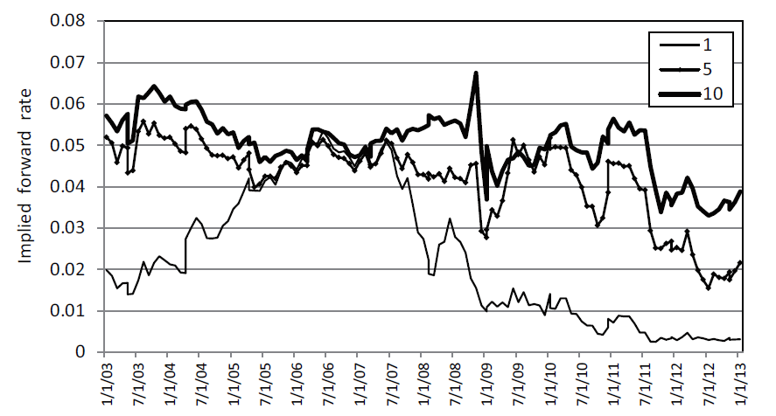
Figure 1. Forward rates in U.S. Treasury market, where the labels 1, 5, and 10 indicate the forward rate over the six-month periods beginning at 1, 5, and 10 years, respectively. Yield data were retrieved from^{[2]}.
We use U.S. Treasury yields from 10 January 2003 to 25 January 2013. Setting $δ=0.5$ (years) and $x_{i}=δ_{i}$ for $i=1,2,…,20(n=20)$, the 6-month forward rate is obtained for every four weeks in this period. Figure 1 shows a historical chart of the implied forward rates. For our numerical examples, we split this sample period into two: period A is the first part, from 10 January 2003 to 4 January 2008, and period B is the last part, from 4 January 2008 to 25 January 2013. Period C is defined as the whole period, from 10 January 2003 to 25 January 2013.
Figure 2 shows the forward rate curves of the three dates that bound the periods. From this, we see a flattening of the forward rates in period A, bull-steepening in period B, and falling in period C. The first rolled trend score $R^{}$ takes a small negative value for period A, and a larger negative value for periods B and C. From (2.5), we may expect that the value of the first market price of risk is negative in period A and strongly negative in periods B and C. For details of this qualitative estimation, see^{[20]}.
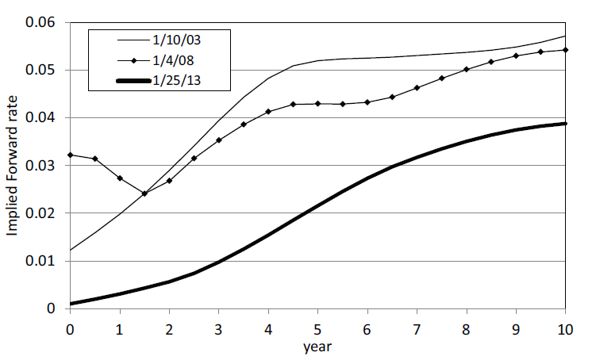
Figure 2. Implied forward LIBOR curves at three days ( 10 January 2003, 4 January 2008, and 25 January 2013).
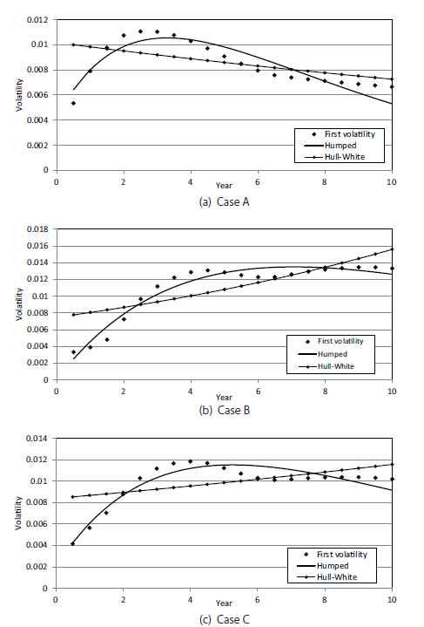
Figure 3. First volatility component with Hull–White volatility and humped volatility
3.2 Volatility fitting
For convenience, we regard the 6-month forward rate as the instantaneous forward rate in our numerical analysis. Setting $Δt=28/365$ (i.e., four weeks), we obtain the volatility components in the HJM model by principal component analysis.
In the following, the numerical examples for periods A, B, and C are referred to as Cases A, B, and C, respectively. The first volatility components are approximated by the Hull–White volatility and by the humped volatility as explained in Section 2.2. Table 1 lists the volatility parameters and approximation error for Cases A, B, and C. In the table, “contribution rate” indicates the contribution rate of the first principal component. We see that the first volatility component explains more than 70% of the covariance for all cases. Figure 3 compares the volatilities of the three cases.
The first volatility component is marked with a dotted curve in Figure 3. From this, the term structure of volatility admits a humped shape in Case A. In Case B, the volatility component is upward convex, rising to the right. Since period C is the direct sum of periods A and B, the volatility structure shows an intermediate shape between that of Case A and that of Case B. It is difficult to approximate these term structures when using Hull–White volatility since the Hull–White volatility is downward convex.
In the humped volatility model, the approximation error is in the range $0.069$–$0.088$ for all cases, which shows that the humped volatility works well for all cases. In the Hull–White model, the mean reversion rate $k$ is negative in Cases B and C since the first volatility component roughly rises to the right. The approximation error is in the range $0.174$–$0.195$ for three cases, which is obviously worse than the error when using humped volatility. Therefore, humped volatility approximates the first volatility component better than Hull–White volatility does for our sample. These features are visually verified in Figure 3 for all cases.

 |  | Case
 |  | A | B | C
Start day |  | 10/1/2003 | 4/1/2008 | 10/1/2003
End day |  | 4/1/2008 | 25/1/2013 | 25/1/2013
Contribution rate |  | 0.823 | 0.725 | 0.738
Humped volatility | $$k$$ | 0.249 | 0.141 | 0.177
 | $$σ$$ | 0.0043 | 0.0001 | 0.0021
 | $$λ$$ | 1.397 | 40.0 | 2.50
 | Error | 0.088 | 0.073 | 0.069
Hull–White volatility | $$k$$ | 0.0337 | -0.073 | -0.0320
 | $$σ$$ | 0.0102 | 0.0075 | 0.0084
 | Error | 0.174 | 0.195 | 0.174
Table 1. Volatility parameters of three cases.
3.3 Estimation of the market price of risk
In the Gaussian HJM model, the market price of risk is estimated for each case by (2.5), using an eight-dimensional model.
In the humped volatility model and the Hull–White model, the market price of risk is estimated by the method described in Section 2.2.
Table 2 compares the market price of risk among the three volatility structures for each case, where “HJM” means the first market price of risk as estimated by the eight-dimensional HJM model, and the values in parentheses represent the difference of the market price of risk from “HJM” in percentage. The market price of risk in “HJM” is $-0.392$ in Case A and $-0.701$ in Case B. Section 3.1 suggests that the market price of risk should be negative and larger in Case B than in Case A. The market price of risk is $-0.594$ in Case C, which is almost an intermediate value between Cases A and B. This is roughly explained by the mean price property, introduced in Section 2.1.
In both the humped volatility model and the Hull–White model, the market price of risk is close to the value of “HJM”. The difference is less than about 1% in all cases. Consequently, there is no remarkable difference in the estimation of the market price of risk among volatility structures. We see that the market price of risk is adequately estimated in the humped volatility model.

Case | HJM | Humped volatility | Hull-White
A | -0.392 | -0.395 (0.83 ) | -0.389 (-0.76)
B | -0.701 | -0.697 (-0.57) | -0.710 (1.30)
C | -0.594 | -0.591 (-0.45) | -0.591 (-0.35)
Table 2. Market price of risk in three cases.
“HJM” indicates the first market price of risk as estimated by the eight-dimensional HJM model, and numbers in parentheses are the percent difference from “HJM”.
4. Conclusion
Here, we presented a practical method for real-world modeling of humped volatility. This model is a generalization of the real-world Hull–White model. Next, we showed numerical examples using U.S. treasury yields from 2003 to 2013. In this period, the term structure of the first volatility component was humped or upward convex. The humped volatility model showed better performance than the Hull–White model on volatility.
The first market price of risk was estimated by using the first volatility component in the Gaussian HJM model, the humped volatility, and the Hull–White volatility. Comparing these values among three volatility structures, there were only small differences. Consequently, we see that the market price of risk is reasonably estimated in the humped volatility model. And the real-world humped volatility model has been practically introduced.
Decralation of Interest Section
The author reports no conflicts of interest. The author alone is responsible for the content and writing of the paper.
References
1. Agca S. The performance of alternative interest rate risk measures and immunization strategies under a Heath-Jarrow-Morton framework. Journal of Financial and Quantitative Analysis 2005; 40(3): 645-669. doi:10.1017/S0022109000001903
2. Board of Governors of the Federal Reserve System. Available from; http://www.federalreserve.gov/releases/h15/data.htm
3. Brace A, Gatarek D, Musiela M, The Market Model of Interest Rate Dynamics, Mathematical Finance 1997; 7:127–155. doi: 10.1111/1467-9965.00028
4. Dempster MAH, Medova EA, Villaverde M, Long-term interest rates and consol bond valuation, Journal of Asset Management 2010; 11: 113–135. doi: 10.1057/jam.2010.7
5. Heath D, Jarrow R, Morton A, Bond Pricing and the Term Structure of Interest Rates: A New Methodology, Econometrica 1992; 61:77-105. doi: 10.2307/2951677
6. Heath D, Jarrow R, Morton, Spindel M, Easier done than said, Risk 1992; 5(9): 77-80.
7. Hull J, White A, Pricing Interest-rate Derivative Securities, The Review of Financial Studies 1990; 3: 573-592. doi:10.1093/rfs/3.4.573
8. Hull JC, Sokol A, White A, Short rate joint-measure models, Risk 2014; October: 59-63.
9. Jamshidian F, LIBOR and Swap Market Models and Measures, Finance and Stochastics 1997; 1:293–330. doi:10.1007/s007800050026
10. Kahn R, Fixed income risk modelling. The Handbook of Fixed Income Securities, Third edition, edited by F. Fabozzi, 1991. p.1307-1319.
11. Mercurio F, Moraleda JM, An analytically tractable interest rate model with humped volatility. European Journal of Operational Research 2000; 120(1): 205-214. doi:10.1016/S0377-2217(98)00382-8
12. Moraleda JM, Vorst TC, Pricing American interest rate claims with humped volatility models, Journal of Banking & Finance 1997; 21(8): 1131-1157. doi:10.1016/S0378-4266(97)00019-8
13. Norman J, Real World Interest Rate Modelling with the BGM Model, SSRN working paper 2009; doi:10.2139/ssrn.1480174
14. Ross S, The recovery theorem. The Journal of Finance 2015; 70(2): 615-648. doi: 10.1111/jofi.12092
15. Stanton R, A Nonparametric Model of Term Structure Dynamics and the Market Price of Interest Rate Risk, Journal of Finance 1997; 52: 1973–2002. doi:10.1111/j.1540-6261.1997.tb02748.x
16. van der Vlies M, Ignorance and Sophistication: the Impact of Heterogeneity on Mortgage Prepayments Doctoral dissertation, Universiteit van Amsterdam, 2016
17. Yasuoka T, LIBOR Market Model under the Real-world Measure, International Journal of Theoretical and Applied Finance 2013; 16(4):1350024(18 pages). doi: 10.1142/S0219024913500246
18. Yasuoka T, Interest-rate Simulation under the Real-world Measure within a Gaussian HJM Framework, Quantitative Finance Letters 2015; 3(1):10-16. doi: 10.1080/21649502.2014.995213
19. Yasuoka T, Correlations between the Market Price of Interest Rate Risk and Bond Yields. Journal of Reviews on Global Economics 2017; 6: 208-217. doi:10.6000/1929-7092.2017.06.19
20. Yasuoka T, Interest Rate Modeling for Risk Management: Market Price of Interest Rate Risk (second edition), Sharjah: Bentham, 2018.
21. Yasuoka T, Evaluating Credit Exposure of Interest Rate Derivatives under the Real-world Measure, J. of Risk Model Validation, to appear.

